We use the isotopic purity calculation for the compound Fipronil-sulfone-13C6 in section 3.2.3 of the main text as an example to demonstrate how our program is used. The compressed file "Isotopic Purity Calculation Program.zip" contains three files: "Isotopic Purity Calculation Program.exe", "Isotopic Purity Calculation [Program.py](http://program.py/)", and "data.xlsx". Both "Isotopic Purity Calculation Program.exe" and "Isotopic Purity Calculation [Program.py](http://program.py/)" can be used to calculate isotopic purity. Considering that using the ".py" file requires the user’s computer to have a specific runtime environment, we recommend using the "Isotopic Purity Calculation Program.exe" for the calculation. Here, we will use the method of "Isotopic Purity Calculation Program.exe" as an example. Please note that regardless of which file you use, either "Isotopic Purity Calculation Program.exe" or "Isotopic Purity Calculation [Program.py](http://program.py/)", the "data.xlsx" file must be located in the same folder as the chosen file. When using our calculation program, the first step is to input the number of 13C atoms, natural C atoms, D atoms, natural H atoms, 15N atoms, natural N atoms, and the theoretical *m/z* value of the completely labeled representative isotopolog ion, as shown in Figure S1. If a compound does not have a certain isotope-labeled, the corresponding natural atom count does not need to be entered. For example, in the compound we are discussing, there is no D-labeled and 15N-labeled, so the count for natural H atoms and N atoms should be filled in as 0. It is important to note that our program can only process singly charged ions.

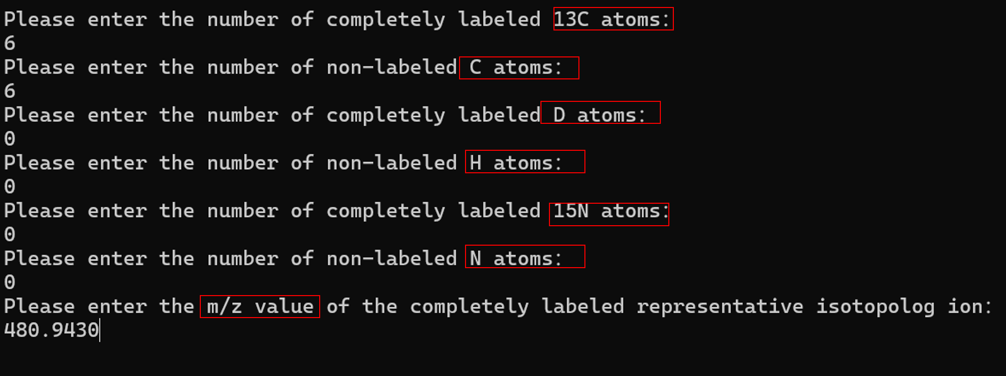

**FIGURE S1.** Input data interface in the calculation program.

We will use the method of exporting data from the Xcalibur software package as an example. First, as shown in Figure S2, change the data viewing mode to "Spectrum list." Then, as illustrated in Figure S3, open "Display Options" and check the "All peaks" option to obtain all mass spectral data within the selected *m/z* range. Finally, as shown in Figure S4, click "Clipboard (Exact Mass)" in the "Export" section to export the mass spectral data, and paste the resulting data into an Excel spreadsheet named "data." Note that the Excel spreadsheet must be named "data" and must be in the same folder as our calculation program. The imported mass spectral data should be formatted as shown in Figure S5, consisting of two columns: the left column for "*m/z*" and the right column for "Intensity."

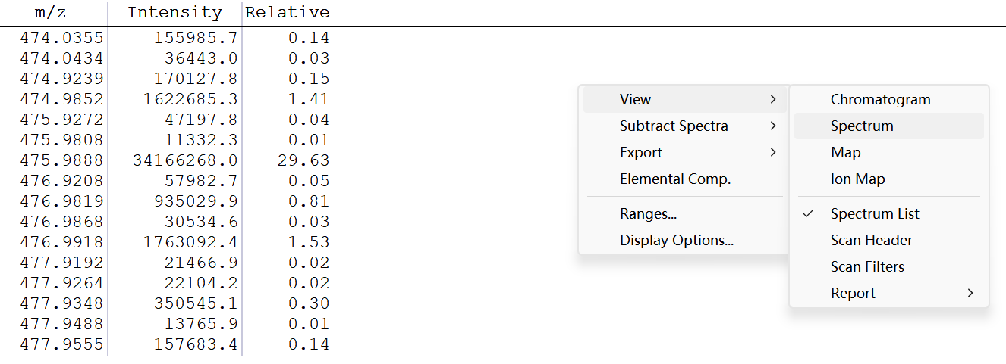

**FIGURE S2.** How to open "Spectrum list".

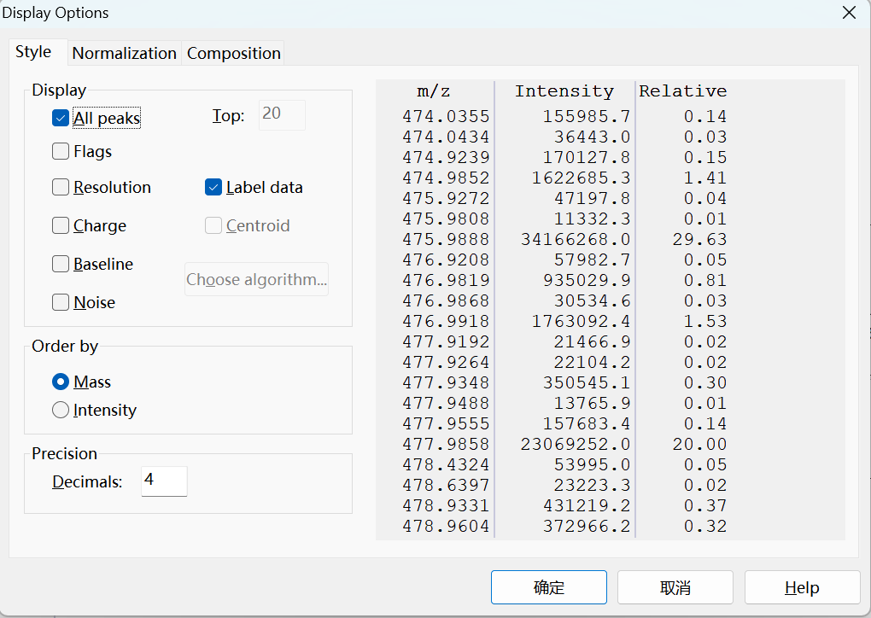

**FIGURE S3.** Select all mass spectral data within the *m/z* range.

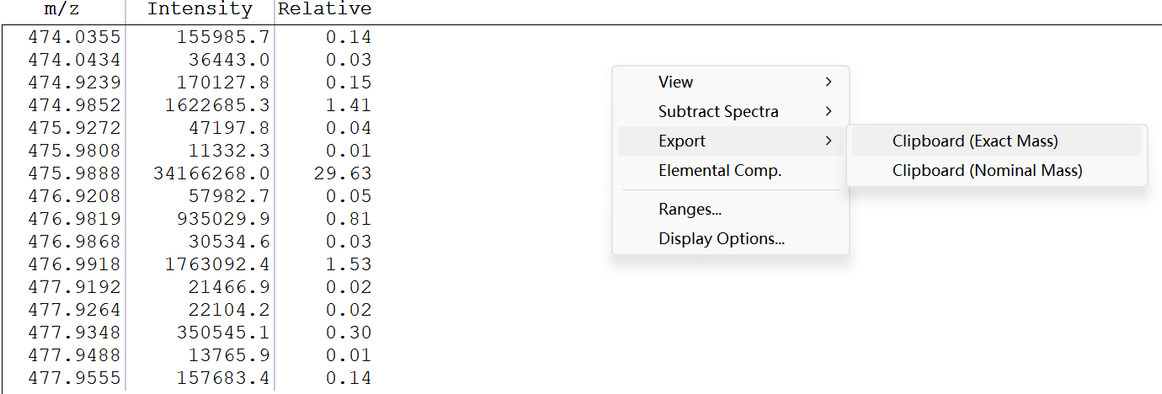

**FIGURE S4.** How to export mass spectral data.

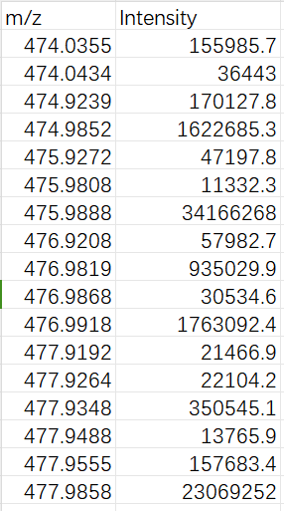

**FIGURE S5.** Format for inputting mass spectral data in Excel.

After completing the above steps, running the program will get our calculation results. The results are displayed in Figure S6. 98.84661440974565% is the isotopic purity of 13C, when rounded to two decimal places, becomes 98.85%. Below this, the isotopic purity for D and 15N is displayed. Since there are no D and 15N labels in this compound, the result is shown as "Not calculate." Please note that when our calculation program calculate mixed-labeled organic compounds, there may be slight differences between the corrected intensity of representative isotopolog ions in the program and the corrected intensity of representative isotopolog ions calculated manually.

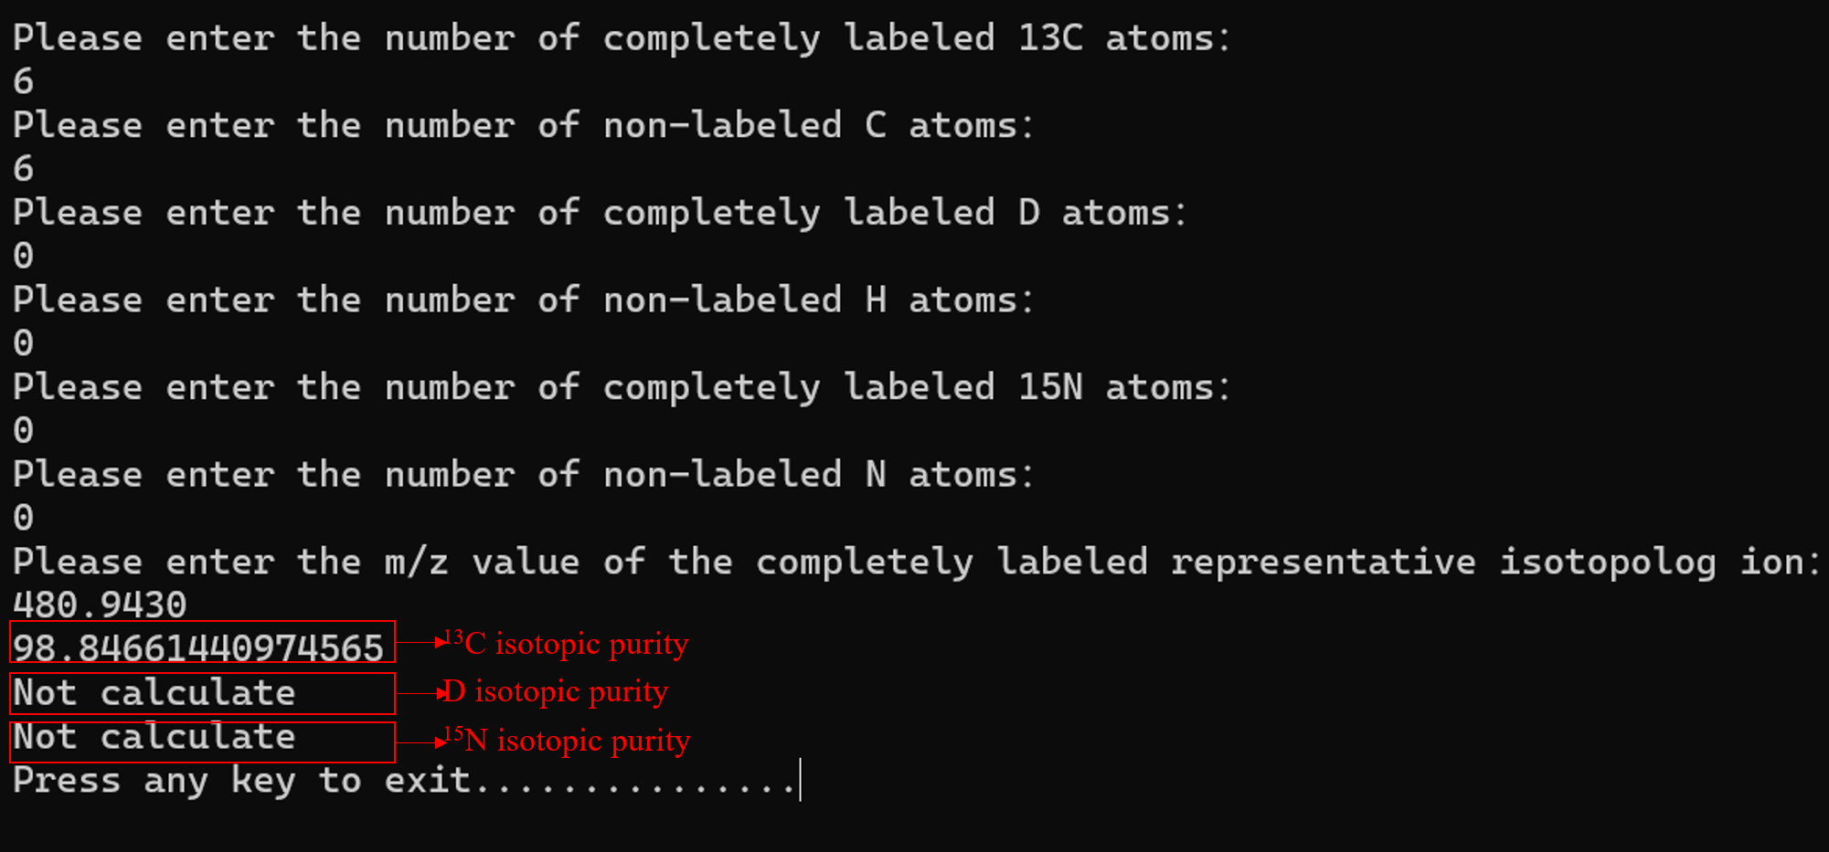

**FIGURE S6.** The output interface of the calculation program.